RMetS Awards and Prizes for 2021
Malcolm Walker Award Application Form
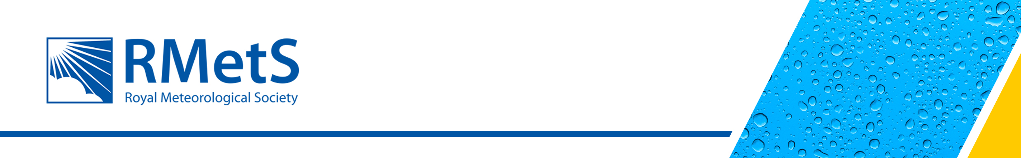
The Royal Meteorological Society recognises and rewards excellence, through its medals, awards and prizes, to people and teams who have made outstanding and exceptional contributions to meteorology and related disciplines. The Society’s awards reflect the breadth of work in the meteorological community and it can be one of the most rewarding activities to honour peers and colleagues for their contributions to the science and profession, and through education and outreach. There are awards that recognise distinguished careers, honour outstanding contributions and reward important and original contributions of early-career scientists.

The Malcolm Walker Award is bestowed annually to recognise and encourage emerging researchers who have brought new insights into an aspect of the environmental sciences, which includes elements of meteorology and/or oceanography. The application should demonstrate that the candidate has an understanding of the historical context of their research and is able to communicate their work to a diverse audience. The application must be supported by the research supervisor(s) responsible for overseeing the work of the candidate which is to be considered for the award.

APPLICATIONS FOR THE MALCOLM WALKER AWARD

The Society invites applications for the Malcolm Walker Award for 2021 that will be presented in 2022. Please send the completed Application Form to the Chief Executive (chiefexec@rmets.org) by 22 October 2021.

APPLICATION FORM

This Application Form is for the Malcolm Walker Award only. Candidates are invited to:

- Complete this Application Form
- Provide a Supporting Statement from the Supervisor(s)/Research Group Leader(s) of the submitted research project including information supporting your suitability for the award in terms of:
- originality of the research;
- its meteorological/oceanographic content;
- understanding the historical context;
- communication skills.
Include the name(s) and affiliation(s) of the supervisor(s) supporting the application.
- Provide a 1 page (max) CV detailing your eligibility as an emerging researcher* and to help assess the place of the submitted project within your research career, including dates and locations of academic achievements and research career to date.

* Emerging researchers are defined as students or researchers who have received their highest degree – undergraduate, masters or doctoral – within the past three years (excluding any parental leave falling in that period with up to one year of parental leave time added per child)

Candidates and supporters should refer to the full regulations for this award at www.rmets.org/awards-and-prizes.

MALCOLM WALKER AWARD APPLICATION FORM

Candidate details
Name: (including title)
Telephone:
Email:
Address:
Affiliation:
Application date: | / / 2021

Research Project
Project title:
Brief statement of the research project - summarising the motivation, methodology and outcomes of the research (max 500 words):

Continued…..

Brief statement of understanding of historical context of the research (max 200 words)

Summary of the research explained in language suitable for a lay audience which has no prior understanding of the topic (max 100 words):

